How do I set up my account to use the Qualitrac Portal?
Please navigate to the Telligen Medicaid Services website (http://idmedicaid.telligen.com) and click on the orange Register button to get started.
Signatures will be completed electronically using DocuSign technology with a final version of the document routed to you for your files. When you receive your final version, our registration team will automatically receive your packet via DocuSign and will process your registration within 5-7 business days.
NOTE: Once processed, new users will receive a Welcome to Qualitrac email with a link to activate their new account. Any questions regarding this process may be sent to qtregistration@telligen.com.

How do I update my address, phone number, or other provider information with Telligen?
Telligen receives updated provider data from Gainwell Technologies (GWT) daily. Please ensure your provider enrollment information is updated with GWT to ensure Telligen has the correct information. Contact information for GWT can be found at:
Idaho Medicaid Contact Information

How can I submit my review if I am having issues with my Qualitrac account or in the process of setting it up?
Providers are required to use Qualitrac to submit prior authorization requests and to upload documentation.
For technical assistance contact the Idaho Call Center and Provider Help Desk.
Email: IDMedicaidsupport@telligen.com
Toll-free phone: (866) 538-9510
For clinical assistance contact Telligen’s CHIS team.
Email: CHIS@telligen.com

While we strongly recommend all providers to create a Qualitrac account, if for some reason you are unable to access the portal, you may appeal directly to Idaho Medicaid for alternative avenues to submit prior authorization requests and submit medical records.
Please email any appeal request to MedicaidQIO@dhw.idaho.gov. IDHW will notify Telligen of all providers that are an exception to this process.

What are the review timeframes for prior authorization requests and Crisis prior authorization requests?
Request Type | Turn-around Time
Initial, Annual, and six-month review requests. | 10 business days
Crisis Intervention | 3 business days
Prior Authorization Amendment | 3 business days
If the request submitted does not include all the required documentation or not enough documentation to render an outcome, Telligen will reach out to request the needed information via a Request for Information letter. This pauses the review time. Once the needed information is received, the review timeframe does not start over, but continues with the remaining days left in the 10-business day or 3-business day time period.

What days are non-business days for Telligen?
Telligen’s offices are closed New Year’s Day, Memorial Day, July 4th, Labor Day, Thanksgiving, and the day after, and Christmas Day.

What is a “Request for Information” letter?
During Telligen’s review of your service request, if any required documentation is missing or any additional information or clarification is needed to finalize the request, you will receive a notification and “Request for Information” or “RFI” letter. The letter will detail what you need to submit to Telligen and request that you include a copy of the RFI letter with your submission. This documentation must be submitted within 10 calendar days. Once an RFI is issued, the time clock for Telligen’s review period pauses until the information is received. If you have questions about the needed information or how to submit it, you may contact Telligen at CHIS@telligen.com or at 866-538-9510.

You have up to 10 calendar days to gather all the requested information and attach it to the case in Qualitrac at one time. It is important to upload ALL requested documentation at once to prevent the reviewers from completing the review process without all the necessary documentation. When this happens, the case could be denied for lack of documentation.

If none of the requested documentation is received within 10 calendar days, a Technical Denial letter will be issued. At this point, you may resubmit the request with complete information. This may affect the start date of any approved services. When services are denied, you may also submit a reconsideration, also known as a 1st Level Appeal, to Telligen including the missing information if you wish. Please note that in cases where the initial denial is due to lack of documentation, if the denial is overturned, approved days will start the day the documentation is submitted.

How do I add additional documentation in response to a Request for Information (RFI)?
To respond to an RFI, you will need to upload the additional or corrected documentation requested. To do this, open the appropriate Case ID, scroll down to the documentation panel, and click the orange “+ Add” button on the right-hand side. If your response to the RFI doesn’t include an additional document to upload, you may email CHIS@telligen.com to discuss your response with Telligen.
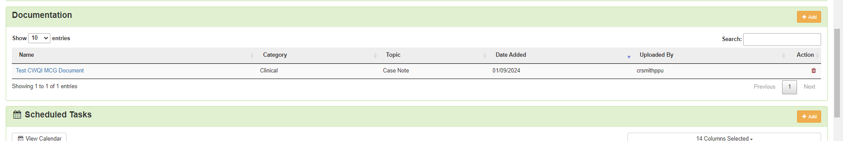

What categories do I select when I submit my requests in Qualitrac?

Review Type
- Outpatient Therapy Intervention.
Place of Service
- Community.
Timing
- Prospective (use for almost all requests)
  - Behavioral Intervention
  - Interdisciplinary Training
  - Habilitative Skill Building
  - Prior Authorization Amendment
  - Crisis Intervention
- Retrospective (only the follow request may be submitted as retrospective)
  - Initial ACTP and Eligibility Determination Screening
Type of Service
- Children’s Habilitative Intervention Services Initial/Annual
- Children’s Habilitative Intervention Services-Crisis
- Children’s Habilitative Intervention Services 6-month Review
- Children's Habilitation Intervention Services-Amendment

What is the “Eligibility Comment” box in the “Coverage Panel” section for?
The Eligibility Comment box in the Coverage section refers to the member’s Medicaid eligibility, not their eligibility for Intervention Services. You do not need to type anything here unless the member’s Medicaid is not active. For example, if you know their eligibility will be active in the next few days, you could still submit the request explaining that situation.

Should I submit my ACTP, Screening, and services all on one request?
No.
Any requests for a different date range should be on their own case.
- Initial ACTPs and Screenings should be on their own requests because they are retrospective and for the date range that they were completed.
- Requests for 96 units/24 hours in 30 days prior to your services starting should also be their own request. (See below for more information on 96units/24-hour requests)
- Crisis Intervention is only for up to 30 calendar days and should be its own request.
  - Crisis Intervention requests must be entered as Prospective.
  - You have up to 72 hours after crisis services begin to submit the prior authorization request.
    - Example
      - Crisis Date: 1/10/2024 (Crisis Intervention Started that day)
      - Request for prior authorization must be submitted by 1/12/2024 and the dates of service requested are 1/10/2024 through 2/8/2024 (30 days).
***Note: You may submit the request anytime within the first 72 hours.

- Behavioral Intervention, Habilitative Skill Building, Interdisciplinary Training and annual ACTPs are all for 6-month timespans, so they could be on the same request.

Please remember to include all required supporting documentation for your initial services request including the ACTP, even though you will have also submitted separately. Prospective annual ACTPs are recommended to be requested on the same case as your 6-month but may be requested any time prior to the annual plan start date.

What documentation do I submit with my prospective annual ACTP request?
It is recommended this be submitted with your 6-month ongoing service request. You will upload the required documentation for that request, enter the procedure code(s) for your services (such as H0004 and associated modifier if applicable), and enter H0032 (and associated modifier) for the annual ACTP. If you submit your annual ACTP request separately from your 6-month ongoing service request please remember that it must still be submitted as a prior authorization, prior to starting the work. You can attach a document stating that you are requesting your annual ACTP prior authorization, the procedure code and modifier, the units needed, and the dates requested. If you request your annual ACTP retrospectively, after you have completed, it will be denied.

How do I submit a request for 96 units (24 hours) for 30 days and when is it allowable?
The 96 units in 30 days can be requested for members who have not received services in the past 365 days. The 96 units can start the same day you submit your initial ACTP.

These will also be submitted as a separate case because they are for a separate date range as other requests for ACTPs and/or the Screening and ongoing service authorizations. The “Service Start Date” will be the date you
submitted your initial ACTP, and the end date would be either 30 days later or the date you intend the services to start, whichever is sooner. For example, if you submitted the initial ACTP on January 1, 2024, and your services are going to start January 30, 2024, your service start and end dates for the 96 units will be January 1, 2024, through January 29, 2024. If you submit your ACTP on January 2, 2024, and your services are going to start January 20, 2024, then your service start and end dates will be January 2, 2024, through January 19, 2024.

The Telligen Review Team understands that submitting requests for this type of service may be difficult. Please reach out to us and we will be happy to walk you through the process.
Email: CHIS@telligen.com

How do I submit a request that allows for multiple providers with different qualifications to provide the approved hours per week interchangeably?
Agencies may request to be able to have flexibility between different provider qualifications to address the member’s needs. This can only be done within the same service such as multiple qualifications for Behavioral Intervention. This cannot be utilized between different services such as Behavioral Intervention and Habilitative Skills Building. Please follow the standard process for submitting the prior authorization request and documentation to Telligen for review and approval. Providers must clearly indicate that they are only asking for “x” hours per week to be used interchangeably between multiple provider qualifications from week to week and ARE NOT requesting “x” hours per week each for all provider qualifications requested. Example:

- H0004 (no modifier) 10 hours per week
- H0004 (HN) 10 hours per week
- Justification must be clear in the Clinical Recommendations section of the members’ ACTP to justify the need for the additional provider qualifications and make it clear that only 10 hours per week are requested, not a total of 20.
If this is approved, providers may not seek reimbursement for more than the total number of clinically recommended units/hours of CHIS authorized per week. This will be monitored and reviewed during QA/QI reviews. For example, in the below example, the provider may only bill for a maximum total of 10 hours per week of CHIS but may use either modifier for the authorized provider qualification, depending on the provider qualification of the staff who rendered the service.

***See the below table for reference.

Dates of Service | Service  (ex: Screening, ACTP, Habilitative Skill Building, Behavioral Intervention, Interdisciplinary Training) | Hours/Units Requested | Notes | Staff Qualification(s)  (ex: Intervention Technician, Intervention Specialist, EBM Intervention Professional) | Procedure Code and Modifier | Provider NPI
Request 1 of 2 (1st 6 months) Service Dates (6 months):

02/01/2024 | Screening | 4 units |  | Intervention Professional | H2000 HO | 12345678
02/01/2024 – 03/14/2024 | ACTP | 32 units |  | Intervention Professional | H0032 HO | 12345678
03/15/2024- 03/31/2024 | Behavioral Intervention | 96 units/ Initial 24 hours |  | Intervention Specialist, Intervention Professional | H0004 HN, H0004 HO | 12345678
04/01/2024 – 09/30/2024 | Behavioral Intervention | 20 hours weekly | Flexibility between multiple providers not to exceed 20 hours weekly | Intervention Professional, Intervention Specialist, Intervention Technician, EBM Intervention Paraprofessional, EBM Intervention Professional | H0004 HO, H0004 HN,  H0004 HA,  H0004, H0004 TG | 12345678
04/01/2024- 09/30/2024 | Interdisciplinary Training | 2 hours weekly |  | Intervention Professional, Intervention Specialist, EBM Intervention Professional | H2019 HT | 12345678
Request 2 of 2 (2rd 6 months) Service Dates (6 months):

10/01/2024 – 03/31/2025 | ACTP | 28 units |  | EBM Intervention Professional, Intervention Professional, Intervention Specialist | H0032 TG, H0032 HO, H0032 HN | 12345678
10/01/2024 – 03/31/2025 | Behavioral Intervention | 20 hours weekly | Flexibility between multiple providers not to exceed 20 hours weekly | Intervention Professional, Intervention Specialist, Intervention Technician, EBM Intervention Paraprofessional, EBM Intervention Professional | H0004 HO, H0004 HN,  H0004 HA,  H0004, H0004 TG | 12345678
10/01/2024 – 03/31/2025 | Interdisciplinary Training | 2 hours weekly |  | Intervention Professional, Intervention Specialist, EBM Intervention Professional | H2019 HT | 12346578

What documentation type do I select in the ‘Documentation’ panel?
There are many documentation types available in Qualitrac. Please select the type that best fits the document you are uploading. If you are unsure what category the document you are uploading fits into, you may select “Additional Documentation to Support”.
- Always choose Children’s Habilitation Intervention Services under Category
- Topic Choices (select the type that best fits the document you are uploading).
  - 6 Month Documentation
  - Annual Documentation
  - Additional Documentation to Support
  - Assessment & Clinical Treatment Plan
  - Crisis Request Form
  - Implementation Plan
  - PA Amendment Form
  - Physician Recommendation Form
  - Service Eligibility Determination Form

What Documentation is required to be submitted with the prior authorization request?
Review Type | Documentation Required | Time frame to request for authorization
Annual Review (member has been authorized for services over the last 365 days) | - The new ACTP  - The new PIP/Implementation Plans  - Copy of the department approved assessment noted in the ACTP (which needs to be completed within 365 days prior to the date the ACTP was signed/dated)  - Annual Review- list of the members objectives, graphs showing change lines (must include 5 of the last 6 months’ worth of date) and a brief analysis of data regarding progress or lack of progress to meeting each objective for the past 6 months. | Request needs to be for 6 months and a prospective request
6-month review | - A list of the child’s objectives  - Graphs showing change lines (must have data for 5 of the last 6 months)  - A brief analysis of data regarding progress or lack of progress for meeting each objective and any needed modifications to assist the member in reaching mastery. | Request needs to be for 6 months and a prospective request
PA Amendment | - PA Amendment- each section must be completed and signed/dated by the provider submitting case and parent/guardian.  - If the provider submitting case is requesting to split hours/units with another provider or take over another provider current authorization, that other provider must also sign/date the PA Amendment form. | Time frame dependent upon request but must be a prospective request (meaning the start date must be the day after case entry or in the future)
Crisis Request | - Crisis request form (completed and signed/dated by provider)  - If the member has not been authorized for services over the last 365 days, the provider must also submit a Physician Recommendation form and Service Eligibility Determination form (Liberty Letter or copy of the Vineland showing eligibility) | Crisis requests must be prospective requests. The start date may be requested 3 days prior to the date of case entry. The total days requests may not exceed 30 calendar days. NOTE: Crisis requests are not to be expected nor planned. They can be entered up to 72 hours after starting Crisis services or the same day as starting services, not before starting services.
Initial Requests for ongoing Behavior Intervention services (member has not been authorized for services over the last 365 days) | - Service Eligibility Determination form (Liberty Letter if applicable and copy of the Vineland. Both forms need to be dated within 365 days of when the ACTP was signed)  - A recommendation from a physician or other practitioner of the healing arts  - The assessment and clinical treatment plan (ACTP)  - Implementation Plans | Request needs to be for 6 months and a prospective request
Initial Request for ACTP units (member has not been authorized for services over the last 365 days) | - Service Eligibility Determination form (Liberty Letter if applicable and copy of the Vineland. Both forms need to be dated within 365 days of when the ACTP was signed)  - A recommendation from a physician or other practitioner of the healing arts  - The assessment and clinical treatment plan | Retrospective request- dates should be the first date noted in the ACTP the provider worked on completing the form and the end date should be the date the provider signed the ACTP- signifying the document was complete.
Eligibility Screening request | - Vineland assessment | Retrospective request- provider should submit this request with the initial ACTP unit request (would have the same start/end dates as noted above for the initial ACTP); however, if the provider is only requesting units (up to 4 for this service), then it would be the start/end date of when the Vineland was completed.
Initial 96 units/24-hour request (member has not been authorized for services over the last 365 days from the when the ACTP was signed) | - Service Eligibility Determination form (Liberty Letter if applicable and copy of the Vineland. Both forms need to be dated within 365 days of when the ACTP was signed)  - A recommendation from a physician or other practitioner of the healing arts  - The assessment and clinical treatment plan (ACTP)  - Implementation Plans | Prospective request- requested start date may be the same date as case entry. This request should not go over 30 calendar days from the start date.

Can I copy demographic information onto a new case when I’m submitting multiple requests for the same Medicaid member at the same time, so I don’t have to retype everything?
Yes. Telligen has a “Copy” feature that allows you to copy a previous request and start a new one. Please be sure to update sections as necessary to reflect your current request accurately.
Please note that this feature is only available once the previous case’s review has been completed by Telligen.
The panels starting with the “Dates of Service” and below- can be edited/updated to reflect the current request. Updated documentation will need to be added to the case. In addition, please be sure to review the procedure code(s) (and associated modifiers) to ensure they are still accurate and make any relevant changes. Continue through the standard process to complete the case.
Please also note that the “Type of Service” cannot be changed from the request you copied. The best practice is to use the copy feature starting with your annual request so that you can copy your initial request and the new request will have the correct service type, you can copy your 6-month request and it will have the correct service type, etc.
Do not copy your initial request. If you copy your initial request to submit your 6-month request, it will have a service type of “Children’s Habilitation Intervention – Initial/Annual” instead of “Children’s Habilitation Intervention Services – 6 Month Review”, which will be incorrect.
The copy feature cannot be used if the previous review type is a Crisis or PA Amendment. If this happens, the review type is incorrect. The case will be closed “Outcome Not Rendered”.
From the Member Hub, identify the Case ID number to be copied. Click on the blue ellipsis (three blue dots) found to the right of the case. A list of options appears. Click on the word “Copy”.
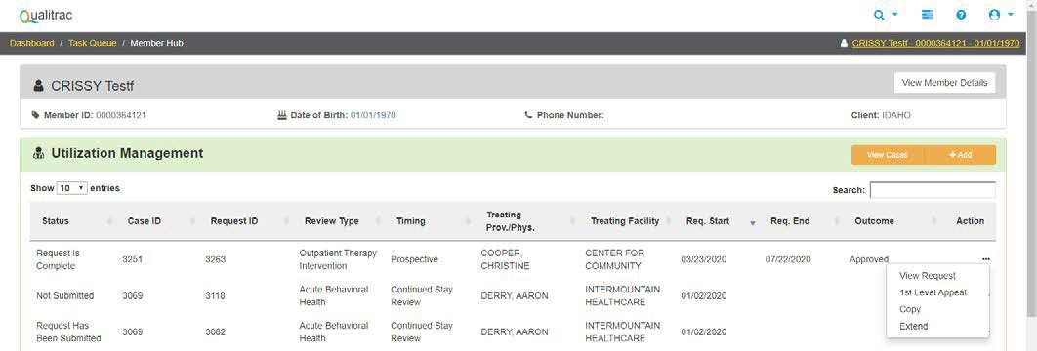

A Confirmation will pop up. Click “Yes” to proceed with the copy.
A new case is created with the same information as the copied case, and it is assigned a new Case ID.

What criteria must be met to meet initial eligibility for CHIS services?

To show functional or behavioral needs the child needs to show a deficit in 3 or more of the following areas: Self-Care, Receptive and expressive language, Learning, Mobility, Self-direction, Capacity for independent living, Economic self-sufficiency, or Maladaptive behavior.
- ABC score at or less than 78
- Communication at or less than 78
- Motor Skills at or less than 78
- Personal at or less than 11
- Community and Coping Skills (both) at or less than 11
- Domestic and Play & Leisure (both) at or less than 11
- Community at or less than 11
- Maladaptive Behaviors (Internalizing or Externalizing) at or more than 19
The Vineland must be submitted with the prior authorization request (See below for Vineland Example).

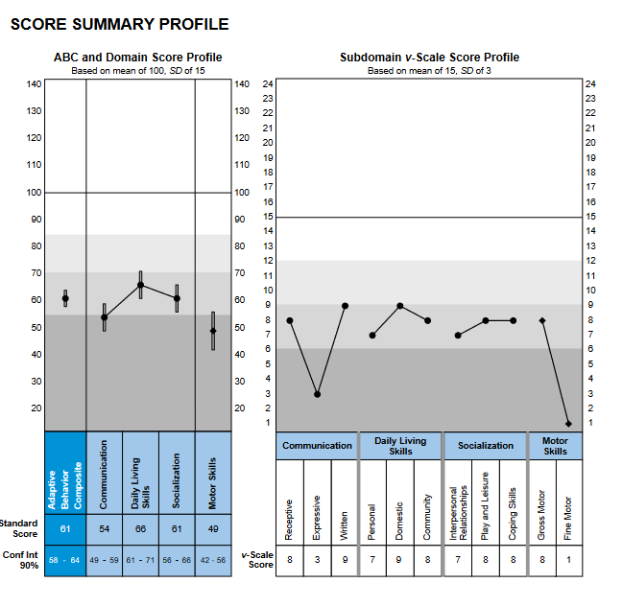

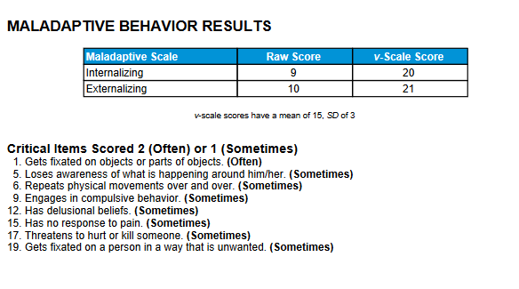

In Qualitrac, what does it mean by “date requested” and does it affect the start date of my member’s services?
The date requested box in Qualitrac is the date that you submitted the request for services. It does not affect the date that the services are approved or the start date of approved services unless you submit your service request after the date you are requesting the services to start. All services except the initial ACTP, Screening, and Crisis must be requested as prior authorizations before you start the service. If they are not, the services can only be approved starting the day after the date requested.

What do I select for the ‘Timing’ box?
- For an initial ACTP or Screening, you will request retrospective timing and enter the date range as the day they were started and completed.
- For a Behavioral Intervention, Habilitative Skills Building, Interdisciplinary Training, and the annual ACTP, you will select prospective timing and enter a future start date and end date.
- For Crisis requests, although they are retrospective services that you would request within 72 hours of starting, you will also enter a request with prospective timing. This is because if you were to enter retrospective timing, the system would not allow you to request future dates for Crisis, and these are generally 30-day authorizations.

In Qualitrac, what should I enter for the start and end dates of services?
For your requests for Annual ACTPs, Behavioral Intervention, Habilitative Skill Building, and Interdisciplinary Training, the start date and end date should be for the appropriate number of months that member’s authorization cycle is on. The start date will be the date you want the intervention services to start and should be a future date because these services are to be prior authorized. For example, if the authorization cycle that the member is on is for 6-months, the services should start on 1/1/2024 and you would enter the end date as 6/30/2024 because this is 6 months. Please see the example below for a prospective request.

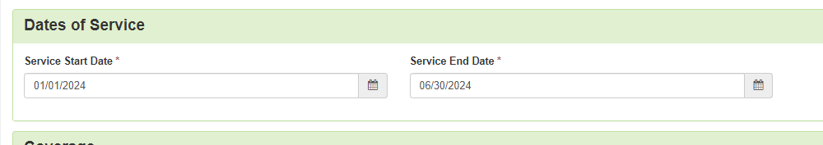

If you are requesting retrospective authorization for an initial ACTP or a Screening, you will enter the start date as the day you began the initial ACTP and/or Screening and the end date as the day it was completed. For example, 1/1/2024 through 1/31/2024. If you are requesting an annual ACTP, please include it in the same case as your ongoing service request as it will be approved for the same timeframe. If you submit your annual ACTP separately from the ongoing service request, please ensure it is still a prospective request and enter the end date as the last day of your approved ongoing service request.

If the date entered in “services start date” does not align with the dates on the ACTP, what date will be used for the start of service?

The start date may be changed by the Telligen review team if does not match the current plan year on the ACTP.

Requested start date of authorization period cannot be on, or prior to date request for services was received. Please note that authorizations for CHIS must be prior authorizations and cannot be backdated to the day or days prior to review submission. Please review IDAPA 16.03.09.570-577 and the CHIS Provider Handbook. If a start date is not prospective, it will be changed by the Telligen reviewer. When a request for information is provided, If all completed documents are not submitted to Telligen via Qualitrac prior to the start date of the next authorization period, it will result in a partial or complete denial of the case (possibly resulting in a gap of Intervention Services).

Will approved services start the day they are authorized, or for the date entered in the “services start date” box?
Approved services will be authorized to start on the date entered in the “services start date” box. The exception to this is if you do not submit your service request prior to the date you are asking the services to start. All services, except the initial ACTP, Screening, and Crisis Intervention, must be prior authorized. For example, if your request is for services to start 1/15/2024, but you do not submit the request until 1/30/2024, any approved services will be authorized to start the day after the request was submitted, 1/31/2024. Please see the next question for how an ACTP and Screening would be authorized. Please also note that the start date will not be the date you are submitting the request.

What will the ACTP, and Screening authorization start dates and end dates be?
Both an approved initial ACTP and an approved Screening will be authorized for the date range in which they were completed, which should be demonstrated by the dates on the ACTP and supporting documentation. In the “services start date” and “end date” boxes, you will enter the date you started and ended/completed the ACTP and/or Screening.

For an annual ACTP, if the prior authorization request is submitted at the same time as the 6-month service request, the start and end dates will be the same as the 6-month service request. If it is submitted separately from the 6-month service request, it must still be submitted prospectively as a prior authorization. The start date would be the date in the future you intend to start the annual ACTP, and the end date will be the same date as your 6-month service request.

What do I put in the “Total Cost” section when I am submitting a request?
This field is not a required field. It does not affect the outcome of the review. Only those Qualitrac fields marked with a red asterisk are required.

Why do I need to put a diagnosis when requesting services when a specific diagnosis is not required for these services?
The field is required, but it does not affect the outcome of the review. Please put a diagnosis relevant to the member.

What do I put in the “Treating Provider”, “Treating Facility”, and “Ordering Provider” boxes?
If you are an agency, you will add your NPI in both the “Treating Provider” and “Treating Facility” sections. If you are an independent provider, you will add your NPI in the “Treating Provider” section and leave the “Treating Facility” section blank. Please be sure to verify that the NPI number that is populated next to your name has been captured correctly and accurately. If an incorrect NPI is submitted, this will affect your ability to bill for services successfully. The “Ordering Provider” section may also be the agency or independent provider requesting intervention services (i.e., all sections could be the same provider), or it could be the member’s primary care provider if it is more appropriate for the situation.

It is important to put the independent provider or agency in the “Treating Provider” section to ensure accurate transmission of information to the Department for billing purposes. This is because whoever is entered in the “Treating Provider” section is the entity that will receive the authorization number to bill with. If the primary care physician is listed under the “Treating Provider” section, the primary care physician will receive the authorization number. Since the primary care physician is not the intervention provider, the request will have to be resubmitted to correctly list the agency or independent provider as the “Treating Provider” for the services.

If I completed an ACTP for a member, but a different provider will be providing all of the intervention services, how do I request the ACTP so I can be reimbursed?
If you completed an initial ACTP, but are not providing the intervention services, you will need to submit the ACTP prior authorization request retrospectively so that you can receive an authorization to bill. The other provider must submit a separate case requesting the hours of services they will be providing and include your completed ACTP as supporting documentation. If you are going to complete an annual ACTP, but not provide intervention services to the member, you must request an authorization for the annual ACTP prior to beginning work on the ACTP. You can do this around the same time as the other provider requests their 6-month services. If you do not do this, you will not be reimbursed. If the other provider requests the annual ACTP on their request for services, the authorization will be given to them, and you will not be able to be reimbursed. You must submit your own request.

If another provider is also providing services to my member, how do we request services?
If this occurs at the initial, ongoing, or annual request, then you each will need to submit your own request including all required supporting documentation. Please be sure to only request the units each of you are using, not the full units on the member’s ACTP, so that each of you receive your own authorization number with the appropriate units on it. You cannot request services for both of you in the same request. If you do this, only the provider who submitted the request will get the authorization for all the units. If another provider is going to start providing some of the services you currently provide part of the way through your authorization period, the other provider will need to submit a PA Amendment Request form that is signed by them, yourself/your agency, and the parent/guardian.

How are monthly Interdisciplinary Training (IT) hours calculated?
Hours approved for IT are multiplied by the months or weeks approved. For example, if you are approved one (1) hour of IT per month for the full 6 months, it would be calculated as 1 hour x 4 units x 6 months for a total of 24 units. If you request IT weekly, it will be 1 hour x 4 units x 26 weeks for a total of 104 units.

How are Behavioral Intervention and Habilitative Skill Building hours calculated?
Hours per week are multiplied by 4 units per hour and 26 weeks (6 months). If the member receives 10 hours per week, then the calculation would be: 10 hours x 4 units x 26 weeks for a total of 1040 units.

If a member needs more hours than initially approved, how do I request these?
Additional hours that need to be added to an authorization for Behavioral Intervention, Interdisciplinary Training, or Habilitative Skill Building must be prospectively requested through Telligen. If this need is identified at the ongoing service request (review), please include an updated ACTP that justifies the need for additional hours in your request to Telligen. If this is needed in the mid-authorization cycle, the request should also include a completed PA Amendment Form in addition to the updated ACTP. Please ensure these are submitted prospectively (prior to the change taking place) as all Behavioral Intervention, Interdisciplinary Training, and Habilitative Skill Building services must be prior authorized.

If I am updating the ACTP because the member needs more hours or services initially anticipated, what do I enter in the “services start date” and “services end date” boxes?
The start date would be the date you want the change to go into effect (this should be a future date because all services must be prior authorized) and the end date would be the same end date as your current authorization period.

Where do I submit my PA Amendment Request Form?
All PA Amendment Forms should be submitted to Telligen via the Qualitrac Portal. Please also ensure you are using the most up to date PA Amendment Form from the website, which can be found at the following link.
State Plan Intervention Provider Forms and Templates

Am I required to obtain the previous provider’s signature on a PA Amendment form?

It sometimes occurs when a new provider is unable to obtain the currently authorized provider’s signature on the PA amendment for a multitude of reasons. The new provider must attempt to obtain a signature on three different dates and at three different times and submit that documentation of these attempts with the PA Amendment form.

For example: an email was sent out to the current/previous provider with the PA amendment form attached on 01/10/2024 at 11 am., a fax was sent out to the current/previous provider with the PA amendment form attached on 01/11/2024 at 3 pm., and then a follow-up phone call on 01/13/2024 at 9 am. The new provider can submit the case at the end of the business day with the documentation of the 3 attempts.

This shows due diligence in obtaining a signature and notification that the family has requested a change in providers. This does not authorize the current/previous provider to ignore the new provider nor allow for the provider to not share the current ACTP with the new provider. This also does not give the prior provider continued authorization with the child.

When a PA Amendment is reviewed and approved, what date will the change take effect?
Any approved changes requested on a PA Amendment form will be approved for the date indicated in the “services start date” box in Qualitrac. This date should match the date written in the “Date of Requested Amendment” box in the “Prior Authorization Amendment Request” section of the PA Amendment Request Form. The PA Amendment Form should also include the dates of the current authorization. You should enter the end date of the current authorization in the “services end date” box in Qualitrac. Please note these also should be done as prior authorizations, not after the change in services has already occurred. If you submit your PA Amendment after the date you are asking to start the change, it will not be approved for the date requested. It will be approved for the day following your submission. If incomplete information is received and a Request for Information must be sent, this also may adjust the start date of your amendment as Telligen cannot approve services to start for a date prior to required documentation being completed and submitted.

What is the review timeframe for PA Amendment requests?
All PA Amendment requests are subject to a three-business day turnaround time. If the request submitted does not include the required justification to make a decision or there are questions about the information submitted, Telligen will reach out to request the needed information or clarification. This pauses the review time. You will need to attach documentation supporting your amendment, such as an updated PA Amendment Form, with the information requested. Once the needed information is received, the review timeframe does not start over, but continues with the remaining days left in the three-business day period.

How long does it take for me to get an authorization number once my request is approved by Telligen?
Cases in Qualitrac that are reviewed will generate an authorization number as soon as the review is complete. The authorization numbers are 7 digits long and generally start with an “8”. They do not have “AUTH” in front of them. If you bill with “AUTH” in front of the number, the billing will be denied.
These authorization numbers are transmitted electronically overnight to GWT and should be visible and billable the next day in GWT. You will see these authorization numbers under “View Authorizations” in GWT’s portal. Authorizations prior to November 2020 will likely be found in “View and Submit Referrals” instead.

If the request is a PA Amendment to an already established authorization, these authorizations are updated manually. The Department is working to update all PA Amendments on the original authorization numbers as quickly as possible. This is generally within 48 hours. Please reach out to medicaidqio@dhw.idaho.gov if you have any questions or concerns.

How can I add or delete documents to a case?
Documents may be added at any time. Open the appropriate case and scroll down to the document panel. Here you can click on orange “+Add” button on the right-hand side.
Documents may be deleted before the case is submitted. To delete a document, click the red trashcan icon under the “Action” on the right-hand side.

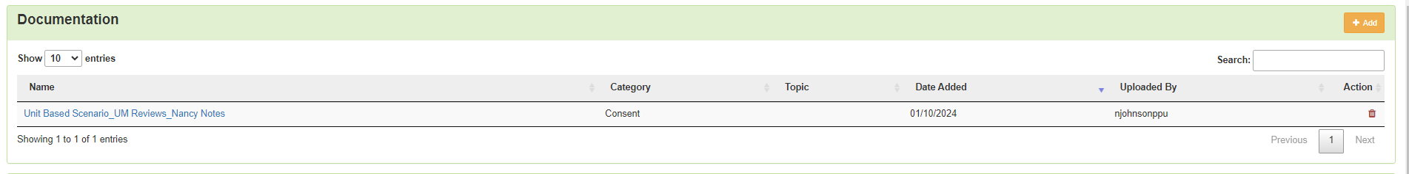

How do I edit or delete a case that I submitted that has not yet been reviewed?
There is a blue Actions drop down on the top right in the Authorization Request Panel. This gives you the option to either edit or delete the request.
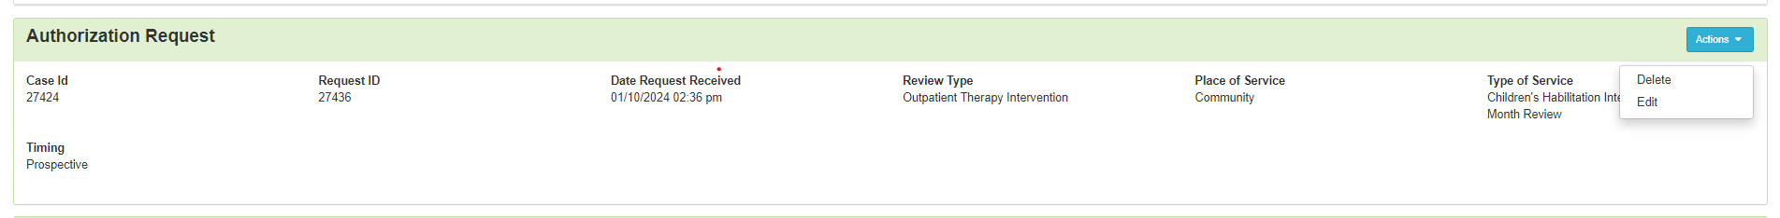

If you opt to delete the case, you will be prompted to verify that you want to delete the request. If you choose Yes, that case will be deleted, and you may submit a new case if needed.

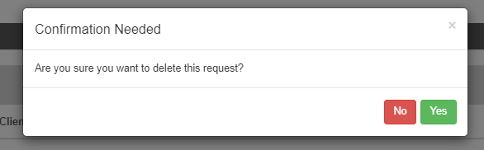

If you opt to edit the request, you may edit any information except the information in the Authorization Request Panel. This includes the Review Type, Place of Service, Type of Service, and Timing. If you entered that information incorrectly, the case must be deleted, and you may submit a new case with the correct information.

All other information may be edited. Scroll down and make changes as needed. For the diagnosis and procedure, you will use the orange “+add” and red trashcan icons as instructed above.

After the changes are made, choose the green continue button on the bottom right of the screen.

You will be prompted to enter your user ID in the User Attestation and to submit the changes.

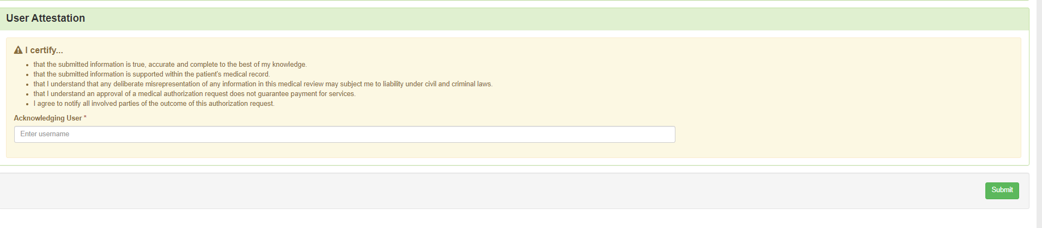

Who do I contact if I see an error with the approved procedure codes/modifiers, units, etc. with my authorization number?
Please contact chis@telligen.com as soon as possible to discuss any errors you may find in your approval. If it is something that needs to be corrected, they will update their system first and then refer the concern to Medicaid to update the authorization in GWT’s system as well.

How do I submit an ongoing or annual review?
To request authorization for the next authorization cycle please submit a new prospective request for prior authorization of the member’s services. The Service Start Date will be the date that you want the intervention services to start, and the end date should be for the appropriate number of months for the authorization cycle that the member is on. For example, if the member is on a 6-month authorization cycle your start and end dates would be March 1, 2024, through August 30, 2024. This will ensure you are provided with an accurate authorization with a unique authorization number for claims payment purposes. A request for the prior authorization of the annual ACTP must be prospective and is recommended to be included in your ongoing service request (review). For more details on what needs to be included when you submit an ongoing or annual review, please reference the Provider Handbook which can be found here:

Developmental Disability Agencies:
Children's Developmental Disability Agencies community-based-services-children-developmental-disabilities/childrens

Independent Providers:
Independent Providers services-children-developmental-disabilities/independent

When should we submit our documents for the initial, ongoing, and annual reviews?
Requests for services should be submitted 30 to 45 days prior to the start date of services. This allows ample time for review and potential requests for information if a review request is incomplete. Please also note that Telligen’s review turnaround time is up to 10 business days/14 calendar days if no Request for Information is needed. Any request submitted more than 45 days in advance will be closed out as “Outcome Not Rendered”.

For additional guidance please visit or contact the following:
Information Releases for providers to review:
Medicaid-providers/information-Medicaid-providers.
Scroll to the bottom of the page and click on “Information Releases”.

Department of Health and Welfare’s Children’s Developmental Disability (DD) Services website for the most up-to-date forms, the Intervention Provider Handbook, and other program information:
DD Program Information

Telligen’s Provider Manual under “Manuals and User Guides”: http://idmedicaid.telligen.com/document-library

Telligen’s Intervention trainings: http://idmedicaid.telligen.com/education-training

If you have questions regarding authorization numbers already loaded in GWT’s system, please reach out to Medicaid at medicaidqio@dhw.idaho.gov or (208) 334-0407.

If you have questions regarding building a case in the Telligen portal or uploading additional documents to an existing case, please email CHIS@telligen.com or contact Miranda Wilkinson at 208-433-7500.

If you need assistance in obtaining credentials for the Telligen portal or need Telligen portal training, please visit https://idmedicaid.telligen.com/ and click on “Provider Portal Registration” in the top right, or contact CHIS@telligen.com.

If you have questions regarding the status of your review, please reach out to Telligen Customer Service at 866-538-9510 or the Children’s Habilitation Intervention Services reviews at CHIS@telligen.com.

For policy questions regarding Children’s Habilitation Intervention Services (CHIS) through Medicaid, please contact ChildrensDDServices@dhw.idaho.gov.

For operational questions regarding Children’s Habilitation Intervention Services (CHIS) through Family and Community Services (FACS), please contact FACSChildrensDD@dhw.idaho.gov.

For questions regarding Children’s Developmental Disability Support Services through Family and Community Services (FACS), please contact FACSChildrensDD@dhw.idaho.gov.

