Change to Concurrent Review submission through the Telligen Provider Portal
Telligen has implemented a change to the process for submitting concurrent reviews through the provider portal. This change has been made to provide a more seamless process for maintaining a single authorization number throughout the submission of two or more reviews for an inpatient stay.
The steps are detailed below:
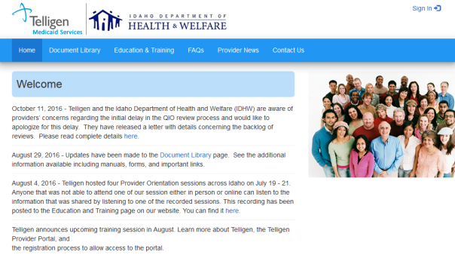
1. Log in to the Telligen Provider Portal at idmedicaid.telligen.com using the Sign In link in the top right hand corner of the page.

2. Use the Add Authorization button on the lower left hand page after you sign in to submit a new review through the Telligen Provider Portal.
3. The system will ask you for details on the type of request that you are submitting. This is where the new questions will be shown when you select "Concurrent" for the admission timing.
When you select "Concurrent" the page will update and display another question.
If this review is related to a previously submitted case, select Yes. The system will then ask you to enter the authorization number for the previously submitted review(s). Submit the Authorization number from the previous reviews(s) and select next to continue the submission.
If this is the initial review for a stay, and no previous reviews related to this stay have been submitted, select No. Then select next to continue the submission.
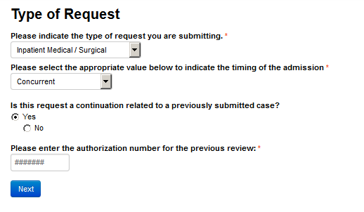

4. These questions will not be displayed when Retrospective or Prospective are selected for the timing of the admission. This will only be for Concurrent review submissions. Everything else for review submission through the portal has remained the same.
5. For questions, please contact the Idaho Call Center and Provider Help Desk by email at idmedicaidsupport@telligen.com or by phone at 866.538.9510

